TO THE ISROMAC 18 SESSION ORGANIZERS:
INSTRUCTIONS FOR THE ABSTRACT SUBMISSION PROCESS IN THE IOP SYSTEM
In this document, instructions to proceed step by step during the abstract submission are provided. Please follow carefully the different steps as indicated. In case of question or doubt, do not hesitate to contact us at information@isromac2020.com.
You have to register in the Submission system main page (https://isromac18.iopconferenceseries.rivervalleytechnologies.com/), you can change your role in “My account” by using “You are logged in as”, see Figure 1.
REGISTRATION
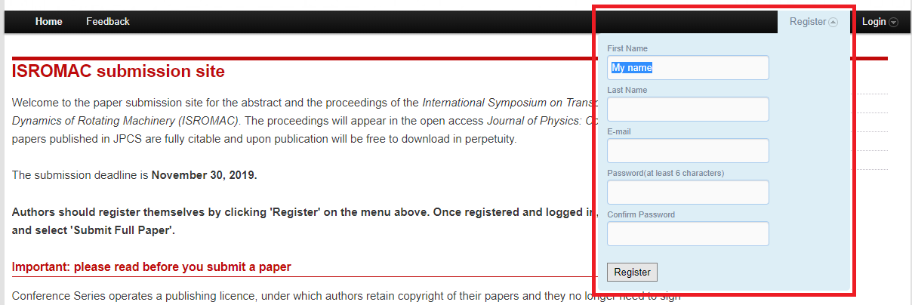
Figure 1 – Submission system main page, registration
Insert your information. After registration you will receive an automated e-mail with your password.
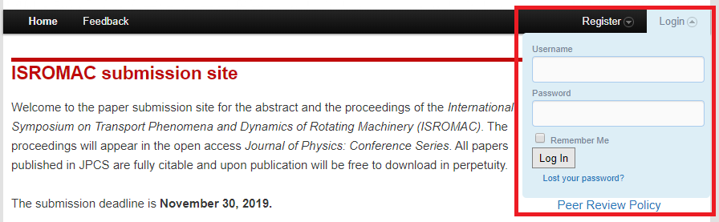
Figure 2 – Submission system main page, login
ABSTRACT SUBMISSION
- After logging in the system, please make sure that you are logged in as “Author”, see Figure 1.
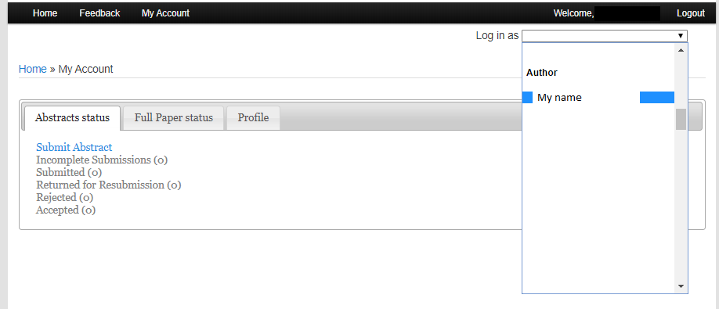
Figure 3 – “My account” page, log in as…
Then, the ‘’Submit Abstract’’ Button will appear, see Figure 4.

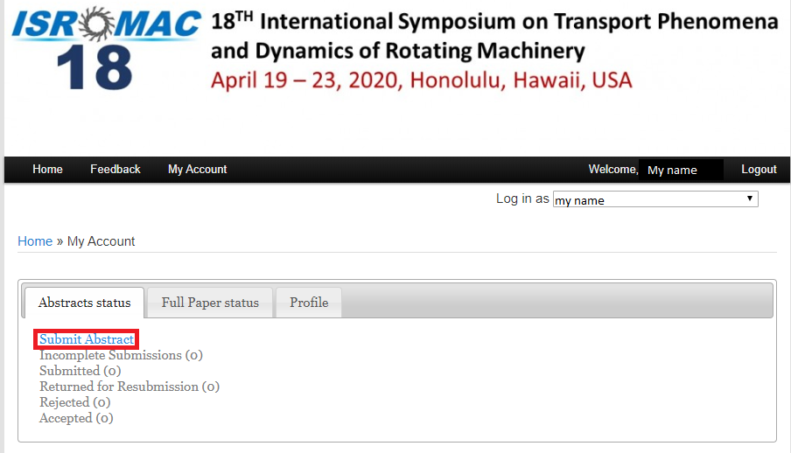
Figure 4 – “My account” page

After clicking the ‘’submit Abstract’’ button, the following page will appear. Please select if you are the only author listed on the paper or not. Use this function if you wish to submit and Extended Abstract.
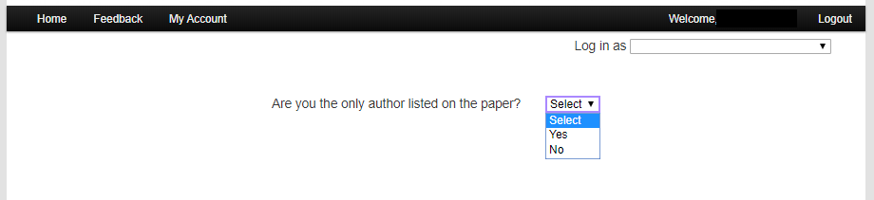

Please Select the ‘’Oral’’ presentation format. Then insert all information about the abstract, including the presenting author, and co-authors, see Figure 6 and Figure 7.
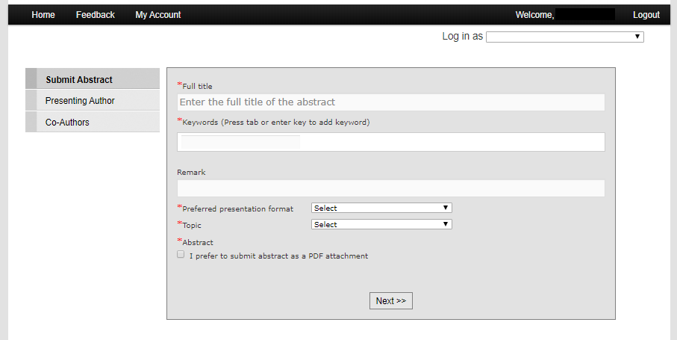
Figure 5 – ‘’ Submit Abstract ‘’ page. Abstract information page.

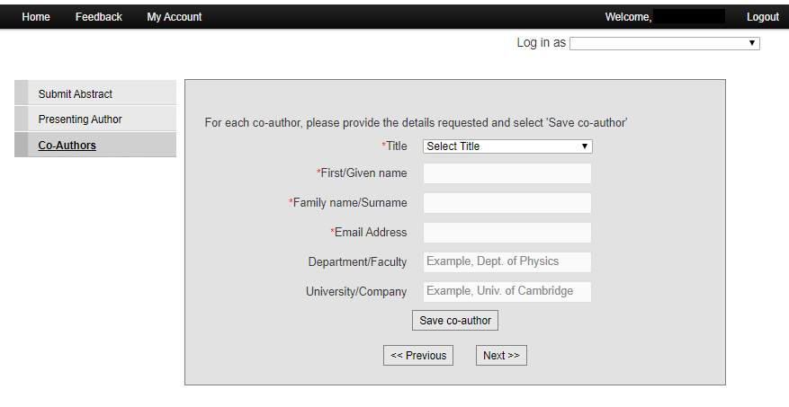
Figure 6 – ‘’ Submit Abstract ‘’ page. Co-authors page.
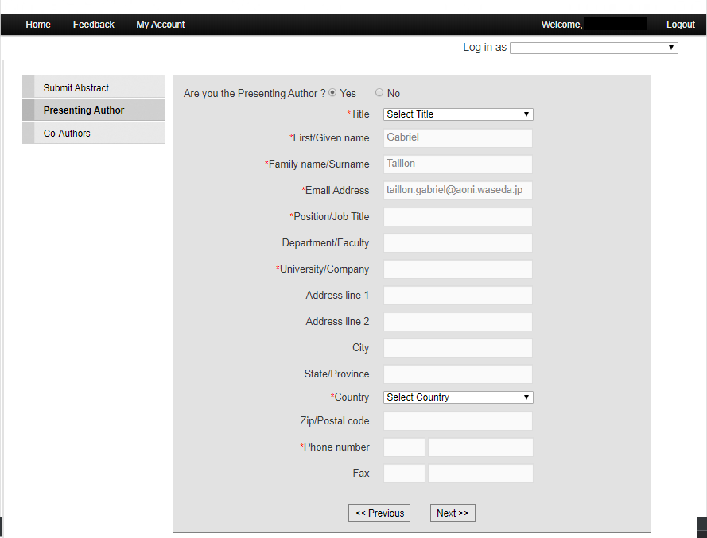
Figure 7 – ‘’ Submit Abstract ‘’ page. Presenting author information page.

After filling the information and clicking next, you will be taken to the “Abstract summary“ page. Please verify that all the information is correct, that you have submitted your pdf file, then you can click on “Submit Abstract Now”. Otherwise you can “Save and submit later”.

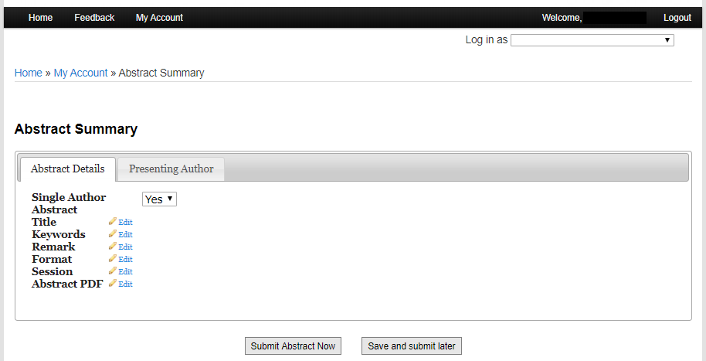
Figure 8 – ‘’ Abstract Summary ‘’ page.

